TUSHAR GULABRAO MOHITE
INCOME TAX & GST PRACTITIONER

78, Shivshakti Sangh, New Sambhaji Nagar, Near Karnatak School, Ghatla, Chembur, Mumbai -400071.

Website : MohiteTax.in E-mail : admin@MohiteTax.in Mobile : 9619156719
Bill No.: 24-09/2017 Date: 14/09/2017

To
Mr. Amol Ananda Chavan,
Chairman, Shree Om Sainath Berojgar Seva Sahkari Sanstha Limited,
116, Gandhi Nagar Rahivashi Sangh, Near Building No. 34,
Chembur Camp, Mumbai – 400074.
Particulars | Amount (Rs.)
OUR FEES FOR PROFESSIONAL SERVICES RENDERED IN RESPECT OF:  - Registration of the assessee under Goods and Service Tax  Bank Name : Mumbai District Central Co-Op Bank Ltd.  Branch : Palton Road, Masjid Bunder, Mumbai  IFSC Code : MDCB0680002  MICR Code : 400068002  Account No. : 00021001009456  Account Type : Savings | 5000.00
TOTAL | 5000.00
Rupees: Five Thousand Only.

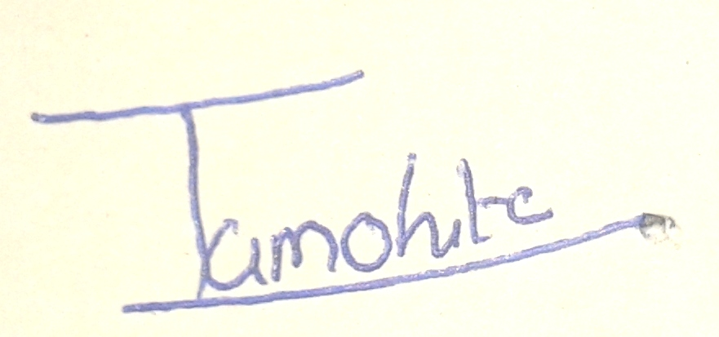

Authorized Signatory

